Q1. Draw a labelled diagram of a typical home Wi-Fi setup showing a modem, router, switch, access point, and at least two devices (like a laptop and smartphone) connected to the network.
Home Wi-Fi Network Architecture
The following diagram shows how different networking devices are connected in a typical home network.
text
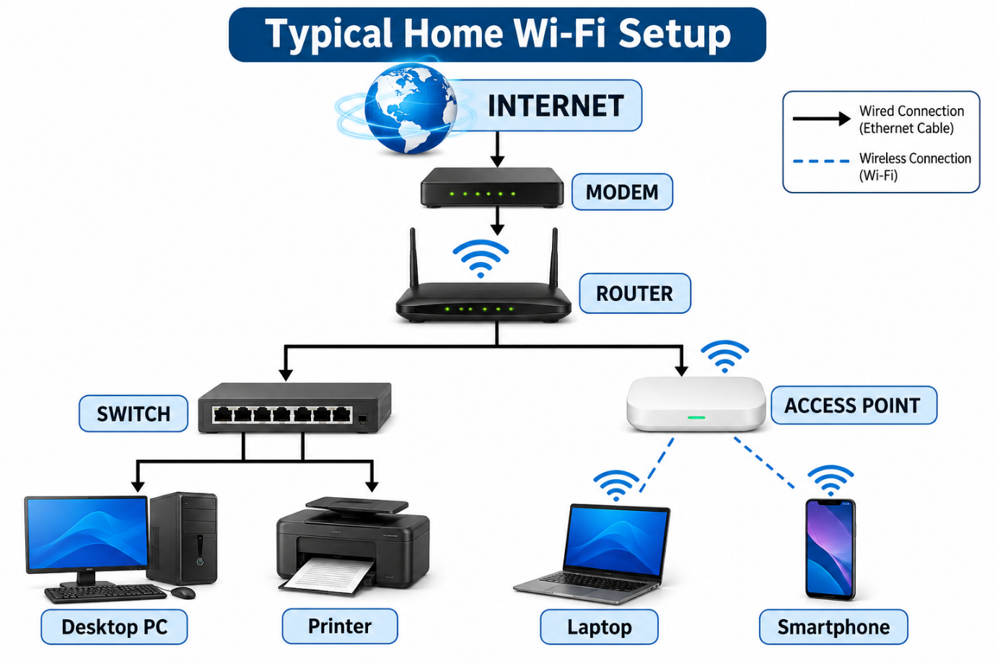

Explanation
- Modem: Connects the home network to the Internet Service Provider (ISP).
- Router: Distributes the internet connection and manages network traffic.
- Switch: Connects multiple wired devices within the same network.
- Access Point: Provides wireless connectivity to devices such as laptops and smartphones.
- Laptop and Smartphone: End-user devices that access the internet through Wi-Fi.

Q2. Main Functions of Networking Hardware Devices
1. Modem
Function: A modem converts signals into a format suitable for communication between the ISP and the home network.
Real-life Example: Used at home to receive an internet connection from a broadband service provider.
2. Router
Function: A router connects different networks and forwards data packets between them. It also shares an internet connection among multiple devices.
Real-life Example: Used at home to provide Wi-Fi to smartphones, laptops and smart TVs.
3. Switch
Function: A switch connects multiple wired devices in a Local Area Network (LAN) and forwards data to the correct destination using MAC addresses.
Real-life Example: Used in offices and computer labs to connect multiple computers.
4. Access Point
Function: An access point provides wireless network connectivity to devices and connects them to a wired network.
Real-life Example: Used in schools, colleges, offices and large homes to extend Wi-Fi coverage.
5. Network Cable
Function: A network cable physically connects networking devices and transfers data between them.
Real-life Example: An Ethernet cable connects a desktop computer to a router or switch.

Q3. Different Types of Network Cables
Network cables are physical transmission media used to transfer data between computers and networking devices. The three common types are:
1. Ethernet Cable (Twisted Pair Cable)
Image Source: https://commons.wikimedia.org/wiki/Category:Ethernet
Description: Ethernet cables contain twisted pairs of copper wires and are commonly used to connect computers, routers and switches in homes and offices.
Common Use: LAN connections, computer labs and office networks.
2. Coaxial Cable
Image Source: https://commons.wikimedia.org/wiki/File:Ethernet_Cat5E_RJ45_cable_%26_coaxial_cable.jpg
Description: Coaxial cables have a central copper conductor surrounded by insulation and a metallic shield.
Common Use: Cable television connections and cable broadband internet.
3. Fiber Optic Cable
Image Source: https://commons.wikimedia.org/wiki/File:SC-APC_fiber_optic_cable.jpg
Description: Fiber optic cables use thin glass or plastic fibers to transmit data through pulses of light at very high speeds.
Common Use: High-speed broadband internet, telecommunications and long-distance data transmission.

Q4. Comparison Between Router and Switch
A router and a switch are important networking devices, but they perform different functions in a network.
Comparison | Router | Switch
Main Use | Connects different networks. | Connects devices within the same network.
Typical Location | Homes and offices. | Offices, computer labs and data centers.
Data Handling | Forwards packets using IP addresses. | Forwards frames using MAC addresses.
OSI Layer | Mainly Network Layer (Layer 3). | Mainly Data Link Layer (Layer 2).
Connectivity | Connects LAN to other networks or the Internet. | Connects multiple wired devices in a LAN.
Main Purpose | Routes data between networks. | Transfers data between devices in a LAN.

